1) Class Diagram:
Category

Category_ID

Name

Par_Cat_ID
Ads

Ad_id
Member_id
Category_id
Name
Ad_description
Date_posted
Price

Member

Member_ID
Member_login
Member_password
Member_level
Name
Email
Phone
location
Scheduler

Link_ID
Name
Category_ID
url
description
approved
add_date

Use Case for Administrator:

Members
Management

Category Management

New Ad

My Classifieds


Links Administration
Admin

Manage
Tasks

View Categories

Manage
Yellow Pages

Search

Use case Diagram for Normal User:

Registration

New Ad

View Categories


View Ads
Member

My Ads

Search

View Yellow Pages

View Links Info

Registration

View Ads

View yellows pages


View Links
Customer

Sequence Diagram for Add a Link:


User Catego- Links Add Update Delete View
ries

select()

option()

new()

edit()

delete()

display()

Sequence Diagram for Project Administration Activities:


Admin Login Admin- Member Category Insert Update Delete
stration
Login()

admin()

choose()

choose()

add()

edit()

delete()
add()
edit()

delete()

Sequence Diagram for Placing an Ad:


User Regi- Login NewAd AdDetails My Class-
stration fieds

register()

login()

new()

details()

setMyAds()

Adlist()

Activity diagram of an Admin Login:
.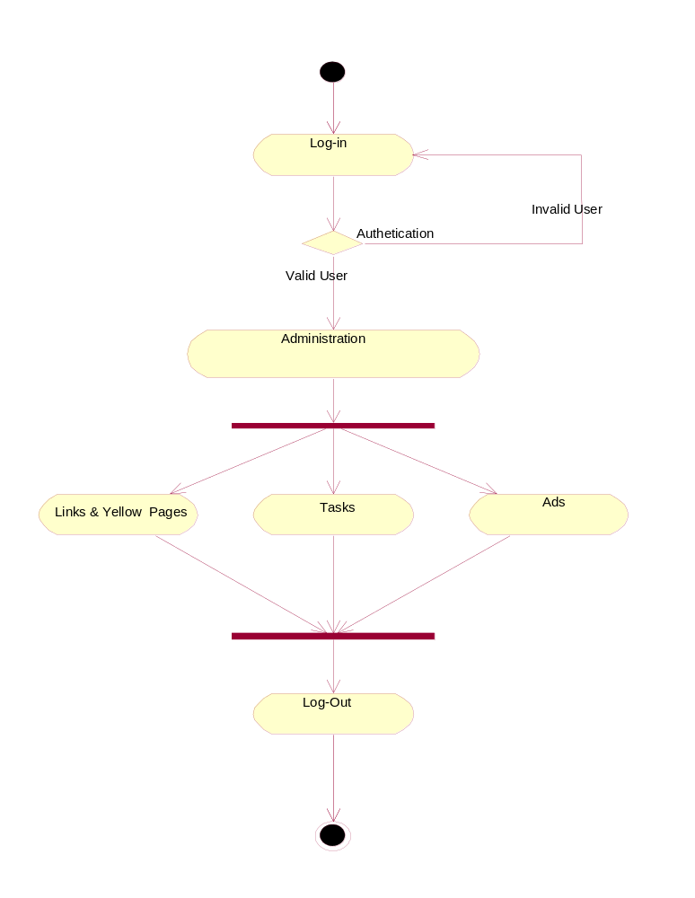

2.Activity diagram for Different types of Issues in the project

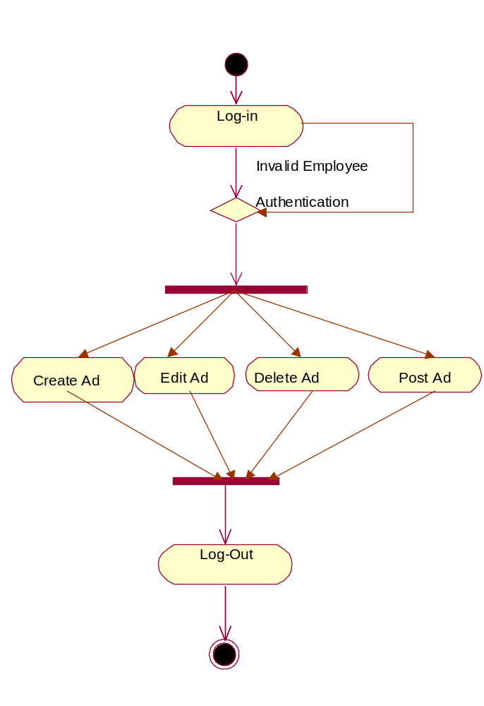

3. Activity diagram for Different stages of the issue.

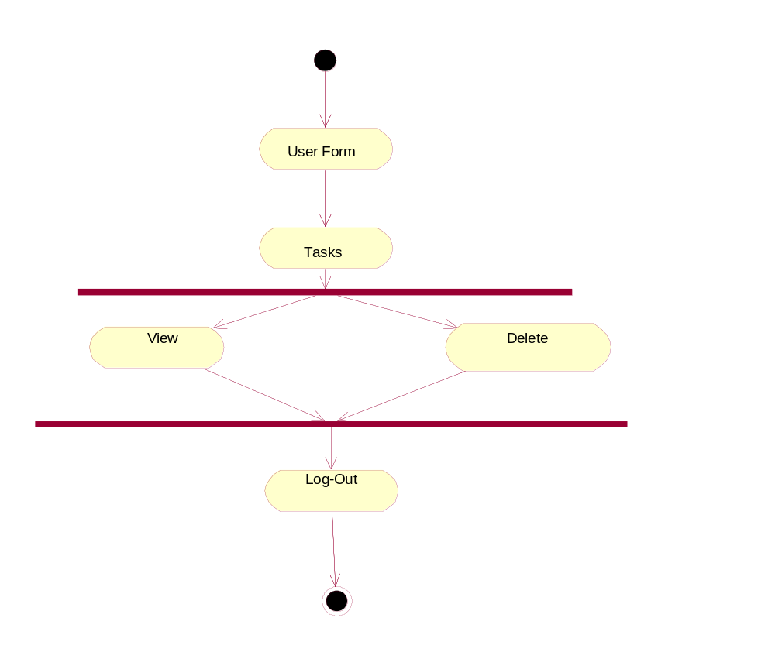

Sequence Diagram Tasks Management:

Login

validate
User Home

Tasks
Assign Task

Update Status

View Tasks

check()

redirects()

select()

add()

update()

View()

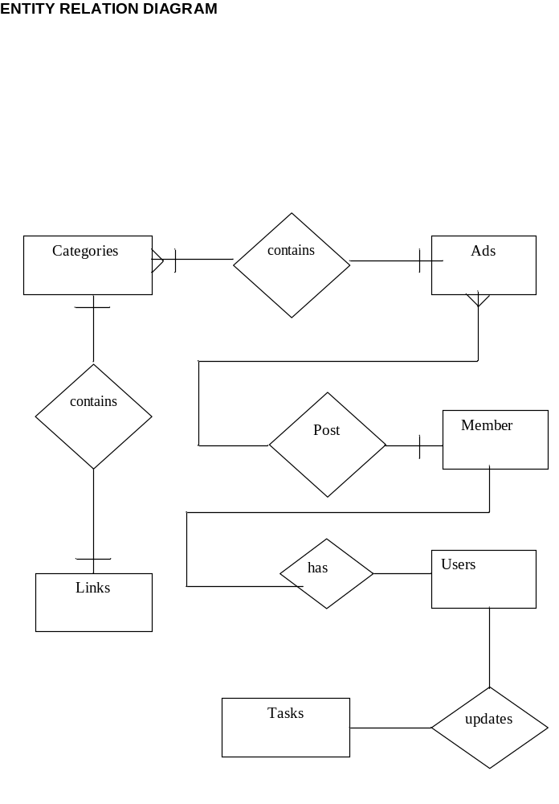
Users

userId
password
userType
Categories

catId
catName
parentCat

Links

taskId
linkName
URL

Yellow pages

yId
yName
yInfo

Tasks

taskId
taskDesc
date
assignedTo
status
dateResolved

Status

statusId
statusName

